**Question 01:**

**Code**

import java.util.*;

class Exercise01{

public static void main(String[] args){

ArrayList<Integer> numbers = new ArrayList<>();

numbers.add(0,4);

numbers.add(1,1);

numbers.add(2,5);

numbers.add(3,8);

numbers.add(4,15);

int n=numbers.size();

int sum=0;

for(int i=0; i<n; i++){

sum=sum+numbers.get(i);

}

System.out.println("The sum of the ARRAY is "+sum);

}

}

**Output**

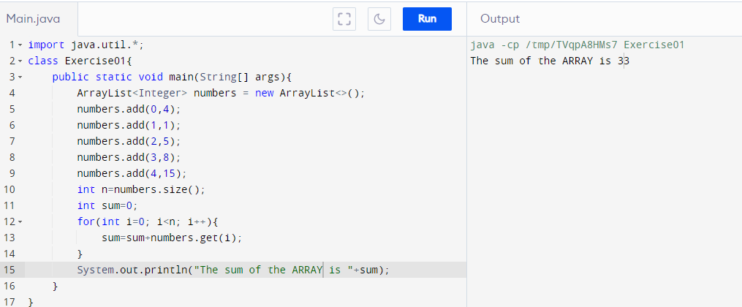

**Question 02:**

**Code**

import java.util.ArrayList;

import java.util.Collections;

class Exercise02{

public static void main(String[] args){

ArrayList<String> a1 = new ArrayList<>();

ArrayList<String> a2 = new ArrayList<>();

a1.add("Mango");

a1.add("Guava");

a1.add("Apple");

a2.add("Banana");

a2.add("Dragon Fruit");

a2.add("Coconut");

ArrayList<String> a3 = new ArrayList<>(a1);

a3.addAll(a2);

Collections.sort(a3);

System.out.println("The first array list is: "+a1);

System.out.println("The second array list is: "+a2);

System.out.println("The final array list in alphabetical order is: "+a3);

}

}

**Output**

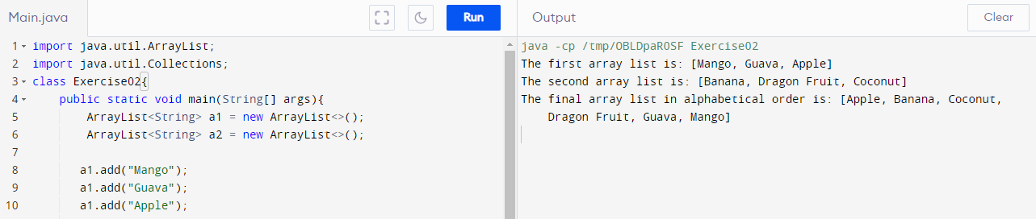

**Question 03:**

**Code**

import java.util.*;

import java.util.ArrayList;

class Exercise03{

public static void main(String[] args){

ArrayList<Integer> onlyodd = new ArrayList<>();

onlyodd.add(0,4);

onlyodd.add(1,1);

onlyodd.add(2,5);

onlyodd.add(3,8);

onlyodd.add(4,15);

int n = onlyodd.size();

for(int i=n-1; i>=0; i--){

int a=onlyodd.get(i);

if(a%2==0){

onlyodd.remove(i);

}

}

System.out.println("The updated array list with only odd numbers is "+onlyodd);

}

}

**Output**

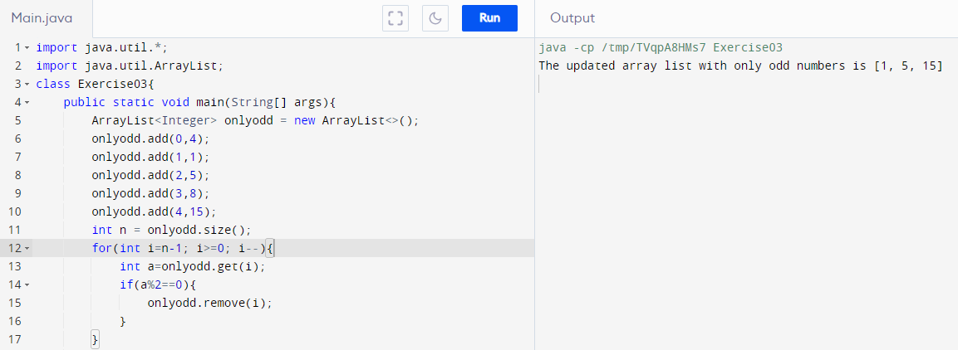

**Question 04:**

**Code**

import java.util.*;

import java.util.ArrayList;

class Exercise04{

public static void main(String[] args){

Scanner myObj = new Scanner(System.in);

ArrayList<Integer> array = new ArrayList<>();

array.add(0,1);

array.add(1,2);

array.add(2,3);

array.add(3,4);

array.add(4,5);

int n = array.size();

System.out.println("The original array list is: "+array);

System.out.println("Enter the rotation:");

int d = myObj.nextInt();

for(int i=0; i<d; i++){

int temp=array.remove(0);

array.add(n-1,temp);

}

System.out.println("The modiified array list is: "+array);

}

}

**Output**

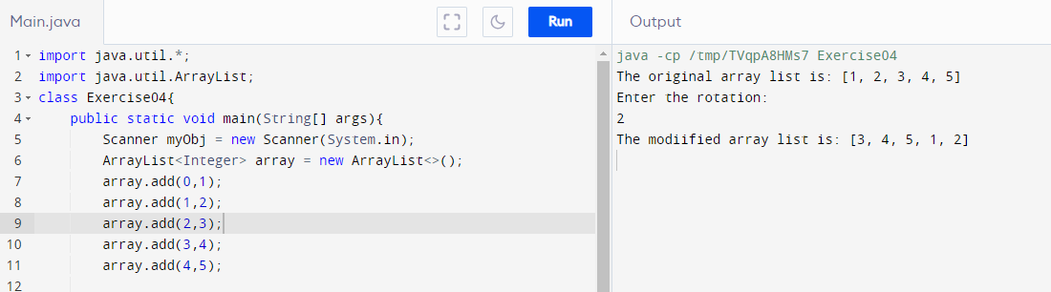

**Question 05:**

**Code**

import java.util.ArrayList;

class Exercise05 {

public static void main(String[] args) {

ArrayList<Integer> a1 = new ArrayList<>();

ArrayList<Integer> a2 = new ArrayList<>();

ArrayList<Integer> a3 = new ArrayList<>();

a1.add(0,1);

a1.add(1,2);

a1.add(2,3);

a1.add(3,4);

a1.add(4,5);

a2.add(0,6);

a2.add(1,7);

a2.add(2,1);

a2.add(3,8);

a2.add(4,4);

int n = a2.size();

for (int i=0; i<n; i++){

for(int j=0; j<n; j++){

int A = a1.get(i);

int B = a2.get(j);

if(A==B){

a3.add(A);

}

}

}

System.out.println("The elements of first array are: "+a1);

System.out.println("The elements of second array are: "+a2);

System.out.println("Common elements in first and second array is/are: "+a3);

}

}

**Output**

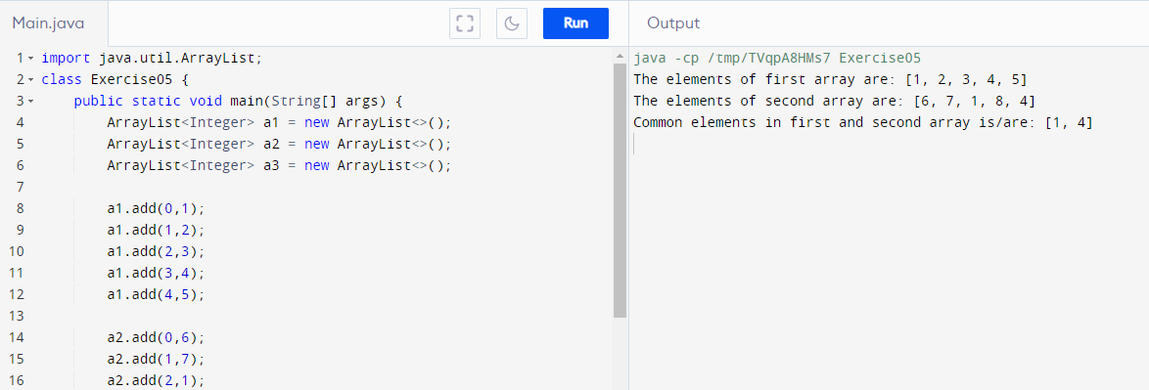

**Question 06:**

**Code**

import java.util.*;

class Exercise06 {

public static void main(String[] args) {

Vector<Double> v = new Vector<>();

v.add(14.75);

v.add(1.002);

v.add(17.1457);

v.add(10.00014);

v.add(9.999999);

int n = v.size();

double sum=0.0, avg=0.0;

for(int i=0; i<n; i++){

sum = sum + v.get(i);

}

avg=sum/n;

System.out.println("The average of vectors of doubles: "+v+" is: "+avg);

}

}

**Output**

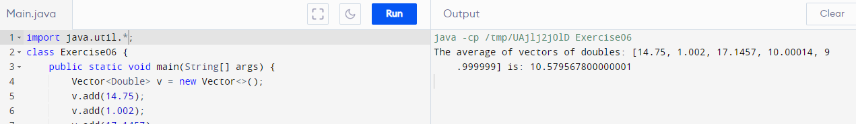

**Question 07:**

**Code**

import java.util.*;

class Exercise07 {

public static void main(String[] args) {

Vector<Character> v1 = new Vector<>();

Vector<Character> v2 = new Vector<>();

v1.add('A');

v1.add('B');

v1.add('C');

v2.add('C');

v2.add('D');

v2.add('E');

int n = v1.size();

Vector<Character> v3 = new Vector<>();

for(int i=n-1; i>=0; i--){

for(int j=n-1; j>=0; j--){

if (v1.get(i)==v2.get(j)){

v1.remove(i);

}

}

}

int n1=v1.size();

for(int i=0; i<n1; i++){

v3.add(v1.get(i));

}

int n2=v2.size();

for(int i=n1-2; i<n2; i++){

v3.add(v2.get(i));

}

System.out.println("The union of the two vectors "+v1+" "+v2+" is: "+v3);

}

}

**Output**

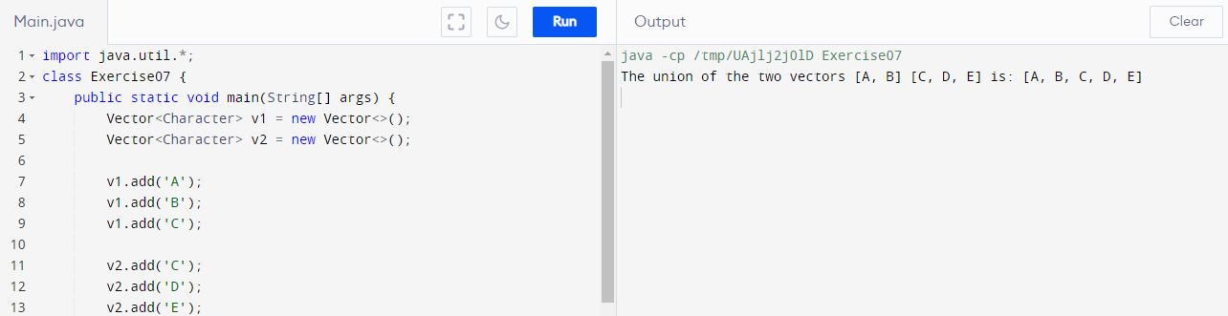

**Question 08:**

**Code**

import java.util.*;

class Exercise08{

public static void main(String[] args){

Vector<Integer> v = new Vector<>();

v.add(1);

v.add(2);

v.add(3);

v.add(4);

v.add(5);

v.add(6);

int n = v.size();

int temp;

for(int i=0; i<n/2; i++){

temp=v.get(i);

v.set(i,v.get(n-1-i));

v.set(n-1-i,temp);

}

System.out.println("The vector in reverse order is "+v);

}

}

**Output**

